International Learning Center

2018–2019 School Calendar

|  |  |
| --- | --- |
| August 20 | Registration/Classes Begin |
| September 3  November 12 | Labor Day – No Classes  Veteran’s Day – No School |
| November 14 | Thanksgiving Celebration |
| November 19-25 | Thanksgiving Break – No School |
| December 5 | Last Day of Classes Christmas Celebration |
| January 7 | Spring Semester Begins |
| January 21 | Martin Luther King Holiday – No Classes |
| February 18 | Presidents’ Day – No Classes |
| March 4–March 8 | Spring Break (UF) – No Classes |
| April 1-5 | Spring Break (Public Schools) – No Classes |
| April 23 | Spring Celebration |
| April 24 | Last Day of Spring Classes |
|  |  |

Would you like to improve your English?

**Join The International Learning Center**

**Fall classes begin August 20**

 **Classes are Monday and Wednesday**

**9:00-11:30 a.m.**

**The International Learning Center**

**Summer Classes are May 16-June 29**

Classes are Monday and Wednesday

9:00—11:30 AM

**Parkview Baptist Church**

3403 NW 13th Street

Gainesville, Florida

3 blocks north of Walmart

**Beginner through Advanced classes**

***August 22***

***Wednesday evening class***

***6:30—8:00 PM***

***Preschool and Children’s***

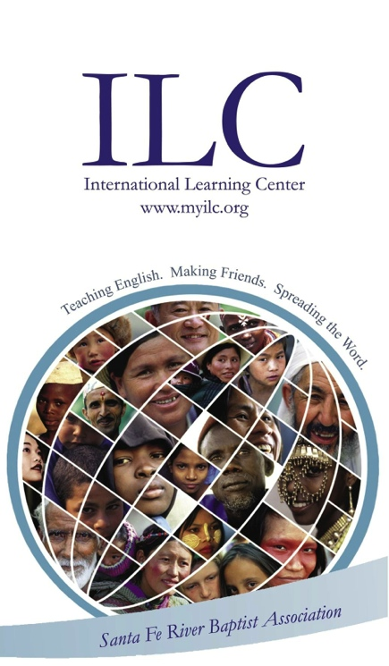***program available***

**Parkview Baptist Church**

**3403 NW 13th Street**

Gainesville, Florida

***Beginner through Advanced classes***

**Tuition: $25 each semester for Evening Class**

**$80 each semester for Morning Class For more formation**

**Nursery for preschoolers (6 months**–**pre‑k) 352-378-2606**

**Refreshments included www.myilc.org**

**May enroll at any class period**